**DEPARTMENT OF COMPUTER & SOFTWARE ENGINEERING**

**COLLEGE OF E&ME, NUST, RAWALPINDI**

**Microprocessor and Microcontroller Based Design**

**Assignment 1**

**SUBMITTED TO:**

**Dr Taimoor Zahid**

**SUBMITTED BY:**

**AMINA QADEER**

**Reg # 0000359607**

**DE-42 (C&SE)-A**

**Submission Date: 30/10/2022**

Assignment 11. Explain/Elaborate the difference with example for thefollowing instruction sets:a. Shift Instructions(SHL, SRL, SAL, SAR)b. Rotate Instructions(ROL, ROR, RCL ,RCR)2. Write a code/program in EMU-8086 that should be able toperform the above instructions.3. Notice the Data and segment register values (binary window)for each instruction and write them down.4. Notice the FLAG register value and write them down.

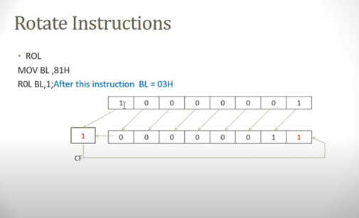

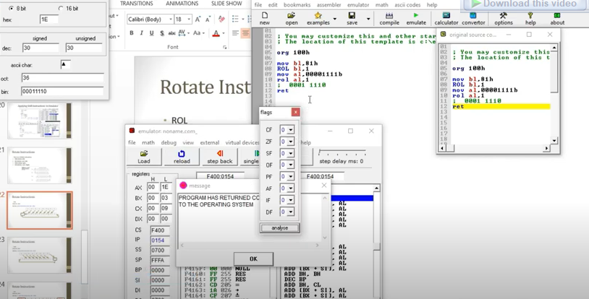

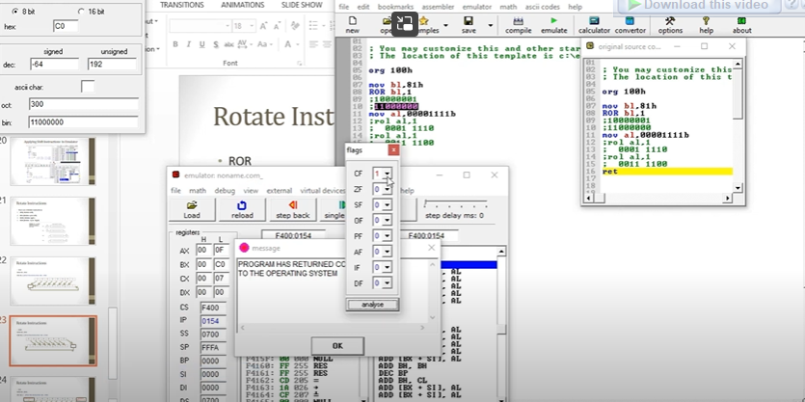

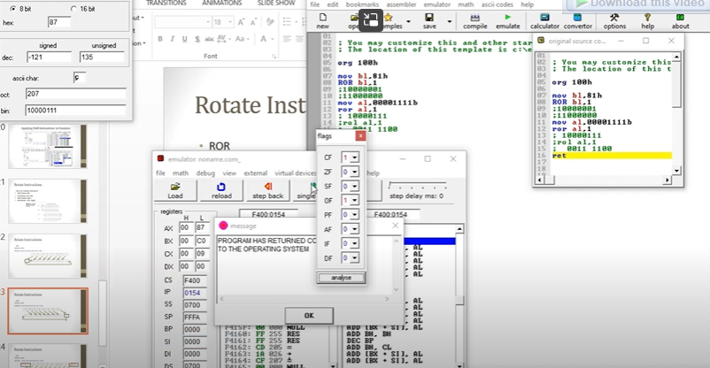

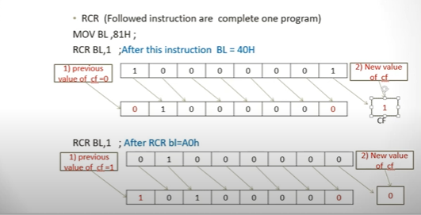

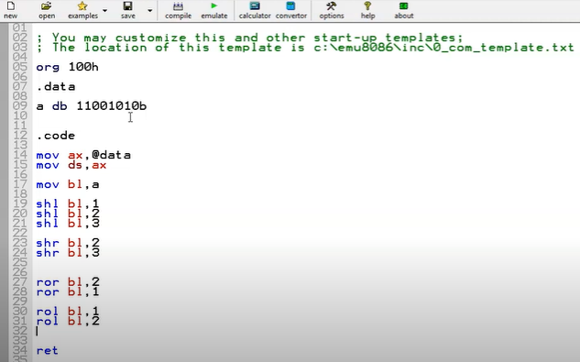

Shift 1

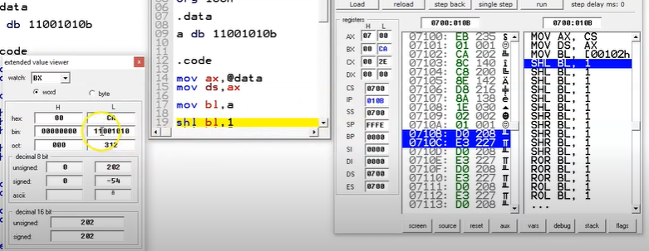

Shift 2

Shift 3

Shr bl 2

Shr bl 3

Ror bl 2

Ror bl 1

Rol bl 1

Rol bl 2

**THE END**